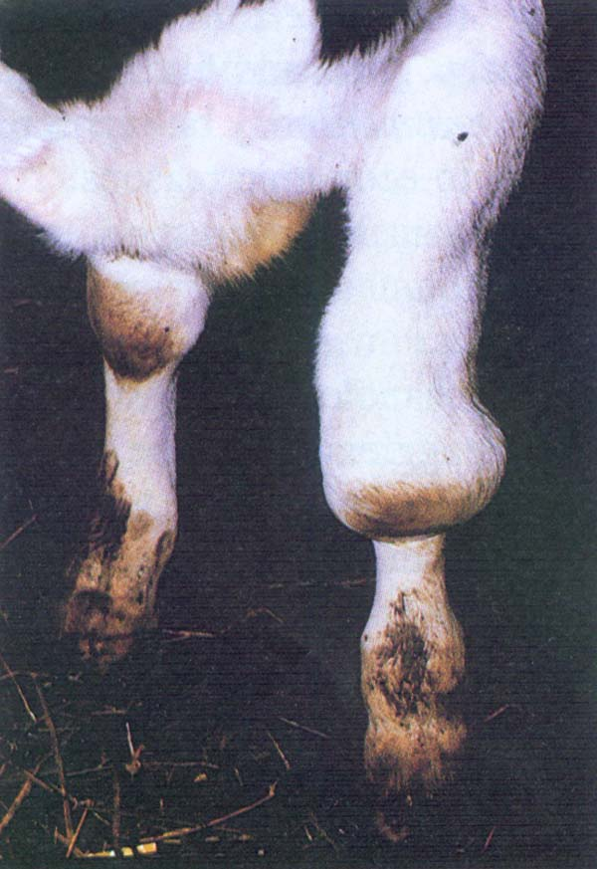

**Organ:** Testis (sheep)

**Lesion:** Edema and swelling of the scrotum.

**Etiology:** *Brucella ovis*

**Diagnosis:** Brucellosis

**Organ:** Cow hind leg

**Lesion:** Hygromas (large fluid-filled subcutaneous sac) on the knee joints of cattle

**Etiology:** *Brucella abortus*

**Diagnosis:** Brucellosis

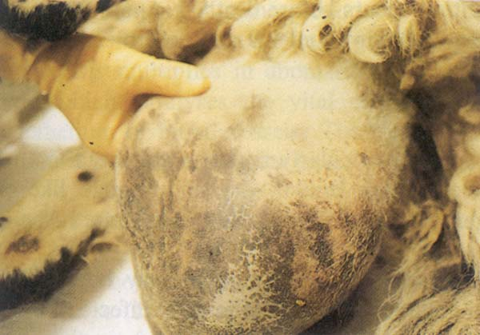

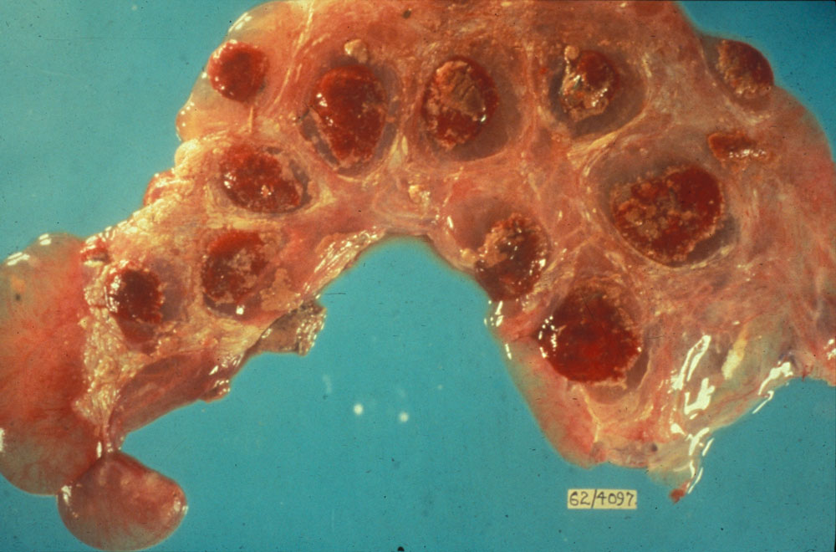

**Organ:** Bovine Placenta

**Lesion:** The placenta contains numerous hemorrhagic cotyledons.

**Etiology:** *Brucella abortus*

**Diagnosis:** Brucellosis

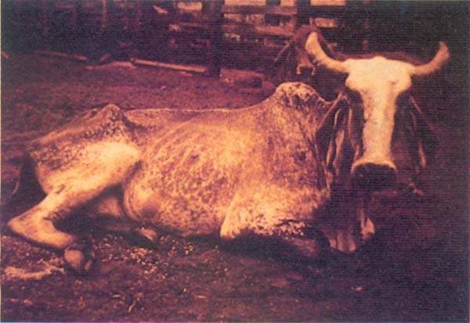

**Animal:** Cow

**Lesion:** Sternal recumbency. Muscular paralysis of hind and front quarters.

**Etiology:** *Clostridium botulinum*

**Diagnosis:** Botulism

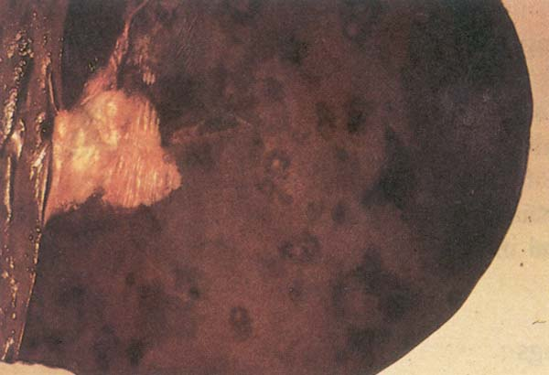

**Organ:** Liver

**Lesion:** Dark brown swollen liver showing necrotic areas (1–2 cm) in diameter surrounded by a zone of hyperaemia.

**Eiology:** *Clostridium novyi*

**Dignosis:** Black disease (Infectious necrotic hepatitis)

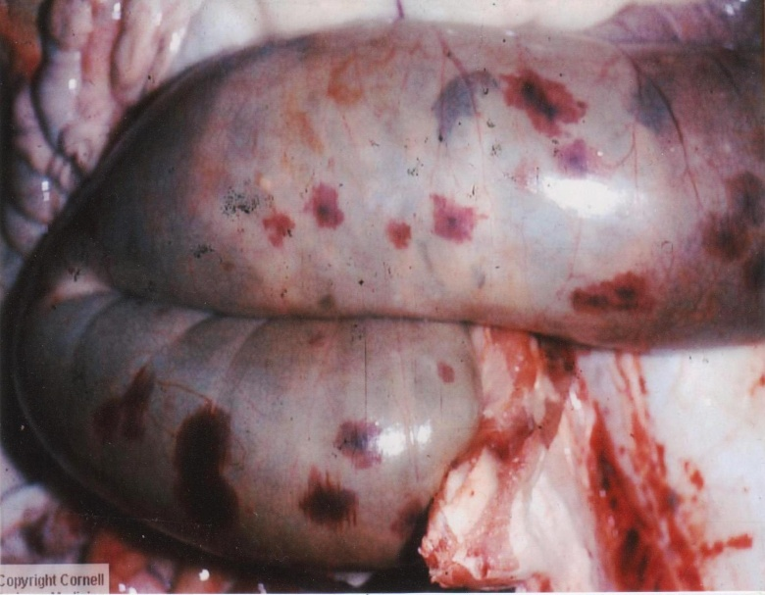

**Organ:** Colon

**Lesion:** The serosal surface showed multiple areas of ecchymotic hemorrhage.

**Etiology:** *Clostridium perfringens*

### Diagnosis: Enterotoxaemia (Pulpy kidney)

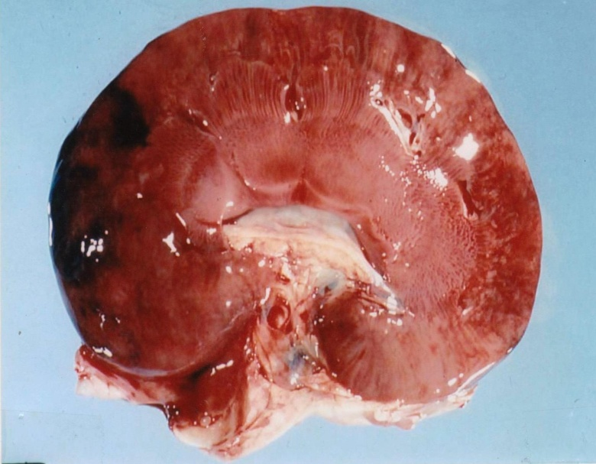

**Organ:** Kidney

**Lesion:** Rapid post mortem autolysis of the kidney (the kidneys is extremely soft) so the name of the disease (pulpy kidney).

**Etiology:** *Clostridium perfringens*

### Diagnosis: Enterotoxaemia (Pulpy kidney)

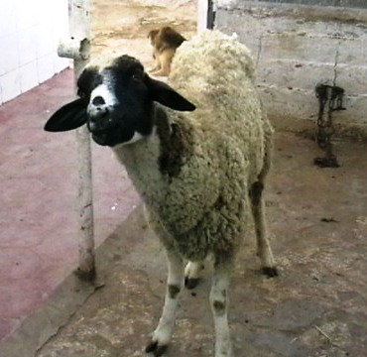

**Animal:** sheep

**Lesion:** Encephalitis, the obvious sign which is lateral deviation of the neck and head.

**Etiology:** *Listeria monocytogenes*

**Diagnosis:** Listeriosis (circling disease)

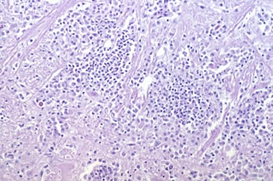

**Organ:** brain

**Lesion:**.Listerial encephalitis (microabcessation) in the midbrain of a cow.

**Etiology:** *Listeria monocytogenes*

**Diagnosis:** Listeriosis (circling disease)

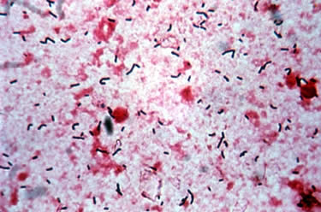

**Organ:** Brain

**Lesion:**.Gram stain (high power). Note the large numbers of V-shaped gram positive bacteria.

**Etiology:** *Listeria monocytogenes*

**Diagnosis:** Listeriosis (circling disease)

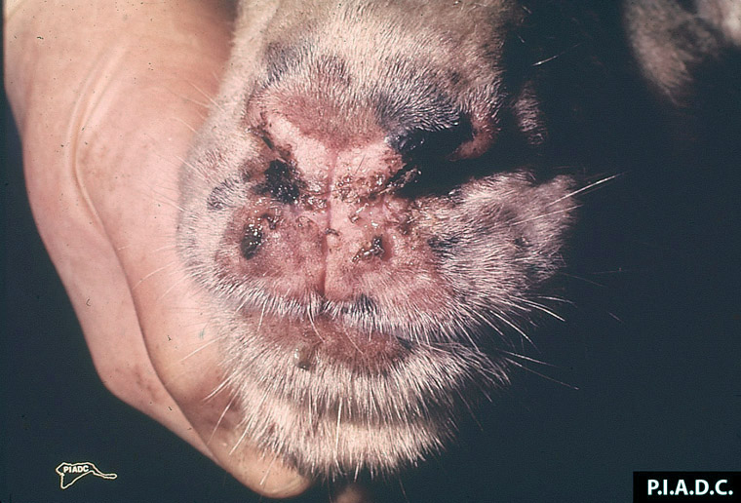

**Organ:** Muzzle (Goat)

**Lesion:** The muzzle contains several papules and partially covered by hemorrhagic nasal exudates.

**Etiology:** goatpox virus (GPV)

**Diagnosis:** Pox

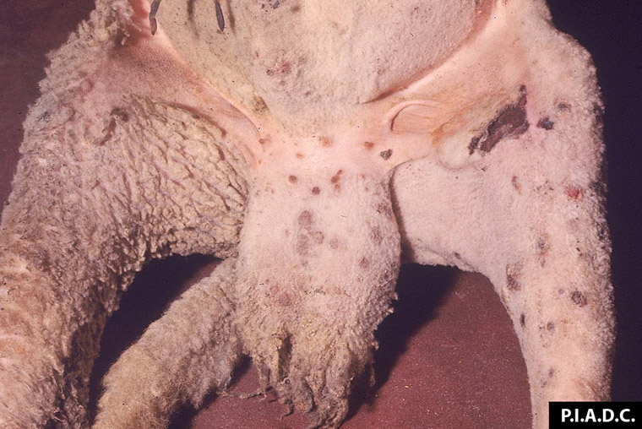

**Organ:** Scrotum and inguinal skin (Sheep)

**Lesion:** There are multiple red brown papules. There are two hemorrhagic ulcers on the medial aspect of the stifle.

**Etiology:** sheeppox virus (SPV)

**Diagnosis:** Pox

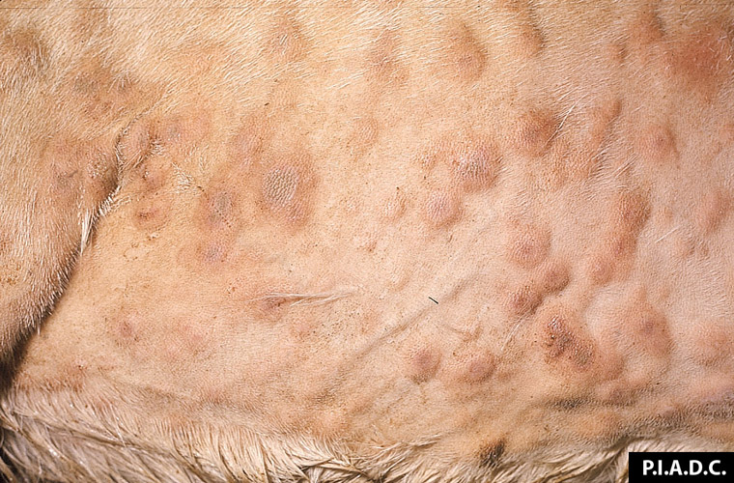

**Organ:** Skin (Goat)

**Lesion:** there are multiple coalescing papules (pox) that often have tan, dry (necrotic) centers.

**Etiology:** goatpox virus (GPV)

**Diagnosis:** Pox

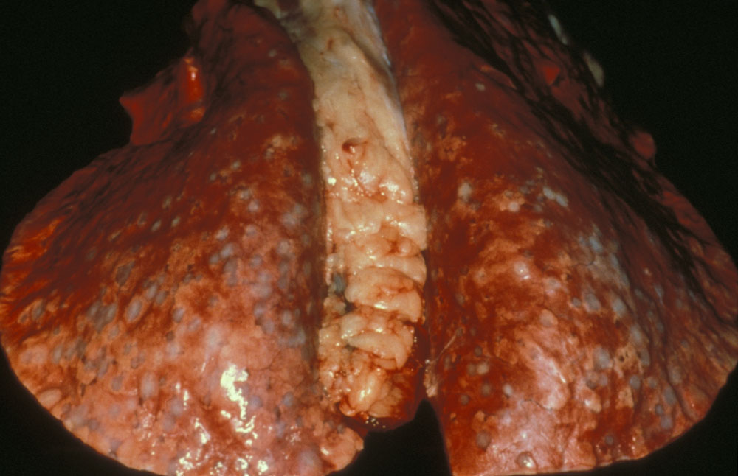

**Organ:** Lung (Sheep)

**Lesion:** there are diffuse granulomatous nodules on the surface of the lung.

**Etiology:** sheeppox virus (SPV)

**Diagnosis:** Pox

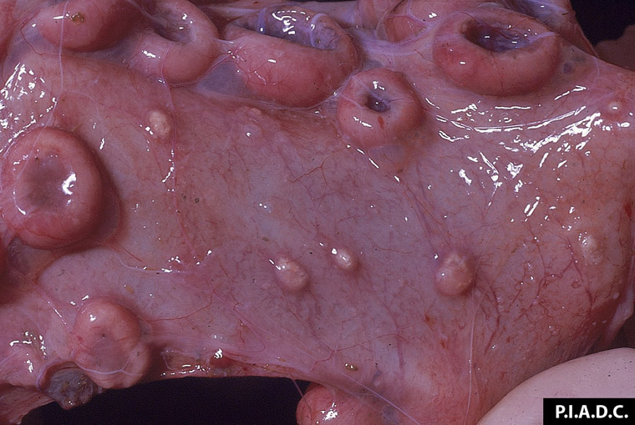

**Organ:** Uterus (Sheep)

**Lesion:** The endometrium contains several tan papules (pox) among the caruncles.

**Etiology:** sheeppox virus (SPV)

**Diagnosis:** Pox

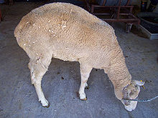

**Animal:** Ewe

**Lesion:** weight loss and hunched appearance.

**Etiology:** prion

**Diagnosis:** Scrapie

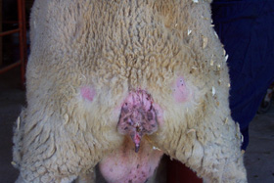

**Organ:** Ewe

**Lesion:** Same ewe as above with bare patches on rear end from scraping

**Etiology:** prion

**Diagnosis:** Scrapie

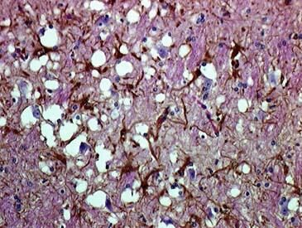

**Organ:** Brain

**Lesion:** Lesions in the gray matter of the brain of a sheep with scrapie: spongiform change and astrocytic hypertrophy and hyperplasia.

**Etiology:** prion

**Diagnosis:** Scrapie